

### Leeming Senior High School

##### Semester Two Examination, 2017

##### Question Paper

### ATAR ENGLISH

##### Year 12 Units 3&4

##### Time allowed for this paper

Reading time before commencing work: ten minutes

Working time for paper: three hours

##### Materials required/recommended for this paper

***To be provided by the supervisor***

This Question Paper

Standard Answer Book

***To be provided by the candidate***

Standard items: pens (blue/black preferred), pencils (including coloured), sharpener,

correction fluid/tape, eraser, ruler, highlighters

Special items: nil

##### Important note to candidates

No other items may be taken into the examination room. It is **your** responsibility to ensure that you do not have any unauthorised material. If you have any unauthorised material with you, hand it to the supervisor **before** reading any further.

##### Structure of this paper

|  |  |  |  |  |  |
| --- | --- | --- | --- | --- | --- |
| Section | Number of questions available | Number of questions to be answered | Suggested working time (minutes) | Marks available | Percentage of examination |
| Section One  Comprehending | 3 | 3 | 60 | 30 | 30 |
| Section Two  Responding | 6 | 1 | 60 | 40 | 40 |
| Section Three  Composing | 5 | 1 | 60 | 30 | 30 |
|  |  |  |  | **Total** | 100 |

##### Instructions to candidates

1. The rules for the conduct of examinations are detailed in the school handbook. Sitting this examination implies that you agree to abide by these rules.
2. Write your answers to each section in the Standard Answer Book.
3. You must be careful to confine your response to the specific question asked and to follow any instructions that are specified to a particular question. If you fail to comply you will be penalised.

Section One: Comprehending 30% (30 Marks)

In this section there are **three** texts and **three** questions. Answer **all** questions.

You are required to comprehend and analyse unseen written and visual texts and respond concisely in approximately 200–300 words for each question.

Suggested working time: 60 minutes.

Question 1 (10 marks)

Explain how Aboulele constructs a distinct voice to build empathy and relate this to the context.

**Text 1**

This extract is from *The Ostrich (1997)* a short story by Leila Aboulele, aScottish writer who lived in Khartoum, Sudan.

“You look fresh out of the Third World”, he says and I feel hurt, glancing downwards so he can’t see the look in my eyes. I don’t answer his teasing smile like he expects me to. I don’t say, “And where do you come from Majdy, or have you forgotten?” I let him put his arm around me by way of greeting and give him the trolley with my suitcases to push. He must have seen me first, I think, while I was scanning faces of people waiting at the terminal; he must have been watching me all the time. I suddenly feel ashamed not only for myself but for everyone else on that aeroplane. Our shabby luggage, our stammering in front of the immigration officer, our clothes that seemed fine a few hours back, now crumpled and out of place. So, I don’t tell him about the baby, even though I had planned to at the airport. Nor do I confess that after two months away, I had longed to stay in Khartoum and not return to London. We wait outside the terminal for the bus to arrive. I had forgotten how wet this country can be. My painted toes stick out of my soaked sandals, a mockery. He looks so well. He tells me he went to a conference in Bath where his supervisor read an academic paper. “There was an acknowledgment of me at the bottom of the first page', he says, ‘the author thanks Majdy El-Shaykh”. I should feel proud but I only feel tired and insincere. I want to feel the baby move inside me but there is only silence while we board the bus.

“You are envied Sumra”, my mother had said, “envied for living abroad where it is so much more comfortable than here. Don't complain, don't be ungrateful.” But when she saw the resentment on my face she softened and said, “It will be easier when you have this baby. Something to fill your day, you will have no time to be homesick then.” Still, I imagined that I could stay there – that I could slip back into my old life and that Majdy would forget me, in time. He would marry an English woman with yellow hair and blue eyes like the ones he admires so much on television. We married so that he would not bring home a foreign wife like so many Sudanese students or worse still, marry and never return. Who wants to go back to the Sudan after tasting the good life of the West? With a Sudanese wife though he would surely have to come back. This is what his family had told me, half in jest. So, I was flattered with presents, a big wedding, a handsome, educated bridegroom and the chance to go abroad. No reason for me to refuse, surely? But now, looking at him, I know I am not strong enough to hold him to his roots. I should not have returned. All my laughter and confidence has been left behind. What am I doing here? A stranger suddenly appearing on stage, a stranger with no part to play, no lines to read.

The next morning as we walk, Majdy casually points out graffiti: *'Black Bastards'* is scrawled on the mosque; *'Paki go home'* on the newsagent's door. What does it mean, who wrote it? I feel the squeeze of fear. How do I recognise these enemies when they so easily recognise me? The woman who sells me stamps, the librarian who can’t spell my name (while the queue behind me grows) the bus driver I anger by not giving correct change (it is my fault, I must obey the sign on the door). Which one of them, in the secrecy of their hearts, agrees with what is written?

Question 2 (10 marks)

Explain how language features communicate controversial perspectives and purpose in Text 2.

**Text 2**

This extract is from the cover jacket flap of *The Whale Warriors* (2007) a non-fiction book by American journalist, Peter Heller.

For the crew of the eco-pirate ship the *Farley Mowat*, any day saving a whale is a good day to die. In the *Whale Warriors*, veteran adventure writer Peter Heller takes us on a hair-raising journey with a vigilante crew on their mission to stop illegal Japanese whaling in the stormy, remote seas off the forbidding shores of the Antarctica.

The *Farley Mowat* is the flagship of the Sea Shepherd Conservation Society and captained by its founder the radical environmental enforcer, Paul Watson. The Japanese, who are hunting endangered whales in the Southern Ocean Whale Sanctuary, in violation of several international laws, know he means business: Watson has sunk eight whaling ships to the bottom of the sea. For two months, Heller was aboard the attack vessel as it stalked the Japanese whaling fleet through the howling gales and treacherous ice off the pristine Antarctic coast. The Sea Shepherd ship is all black, flies under the Jolly Roger flag, and is outfitted with a helicopter, fast assault Zodiac inflatables, and a seven-foot blade attached to the bow, called the can opener.

As Watson and his crew see it, the plight of the whales is also about the larger crisis of the oceans and the eleventh hour of life as we know it on earth. The exploitation of endangered whales is emblematic of a terrible exploitation of the seas that is now entering its desperate conclusion. The oceans may be easy to ignore because they are literally under the surface, but scientists believe that the world’s oceans are on the verge of total ecosystem collapse. Our own survival is in the balance.

In the ice-choked water a swimmer has minutes to live. The Japanese factory whaling ship, the *Nisshin* *Maru,* is ten times the tonnage of the *Farley Mowat* and sailors know there will be no rescue in this desolate part of the ocean if anything happens. Watson presses his enemy while Japan threatens to send down defence aircraft and warships, Australia appeals for calm, New Zealand dispatches military surveillance aircraft, the U.S. Office of Naval Intelligence issues a piracy warning, and international media begin to track the developing whale war. For the Sea Shepherds, there is no compromise. If the charismatic, intelligent Great Whales cannot be saved, there is no hope for the rest of the planet. Watson aims his ship like a slow torpedo and gives the order: “Tell the crew, collision in two minutes.” In 35-foot seas, it is a deadly game of Antarctic chicken in which the stakes cannot be higher.

Question 3 (10 marks)

Explain how visual elements influence interpretation in Text 3 and compare the impact of this medium to Text 2.

**Text 3**

This is a black and white version of the cover of the non-fiction book, *The Whale Warriors* (2007).

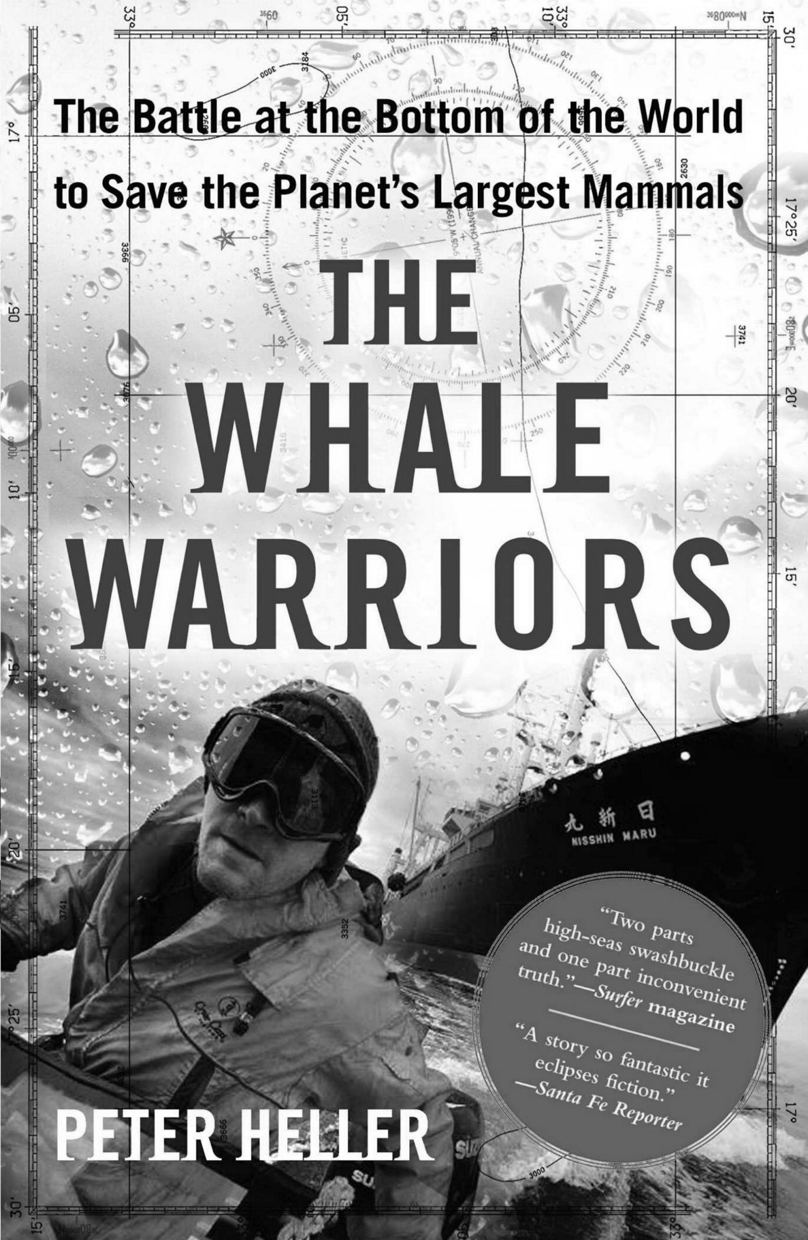

**End of Section One**

**This page has been left blank intentionally**

**Section Two: Responding 40% (40 Marks)**

In this section there are **six** questions. Answer **one** question.

In the form of an **essay**, your response should demonstrate your analytical and critical thinking skills with reference to any text or text type you have studied.

Suggested working time: 60 minutes.

Question 4 (40 marks)

Discuss how at least **one** text immerses you in a dramatically altered world and consider why such texts resonate.

Question 5 (40 marks)

Compare **two** texts and explain how expectations of genre, mode or media are met or subverted.

Question 6 (40 marks)

Explain how recurring elements have significance and extend meaning in at least **one** text.

Question 7 (40 marks)

Compare how **two** texts represent the experience of the ‘outsider’ to challenge assumptions.

Question 8 (40 marks)

Reflect on how at least **one** text represents and evaluates society through a set of values and attitudes.

Question 9 (40 marks)

Discuss how a **specific** multimodal text generates debate through its content and point of view.

**End of Section Two**

**This page has been left blank intentionally**

**Section Three: Composing 30% (30 marks)**

In this section there are **five** questions. Answer **one** question.

You are required to demonstrate writing skills by choosing a form of writing appropriate to a specific audience, context and purpose.

Suggested working time: 60 minutes.

Question 10 (30 marks)

‘Every day it was tomorrow that I’d be able to do it, and each day it became more difficult…’

Compose a text that interprets the concept of procrastination, in a form of your choice.

Question 11 (30 marks)

Compose an imaginative text that experiments with language features in response to this image.

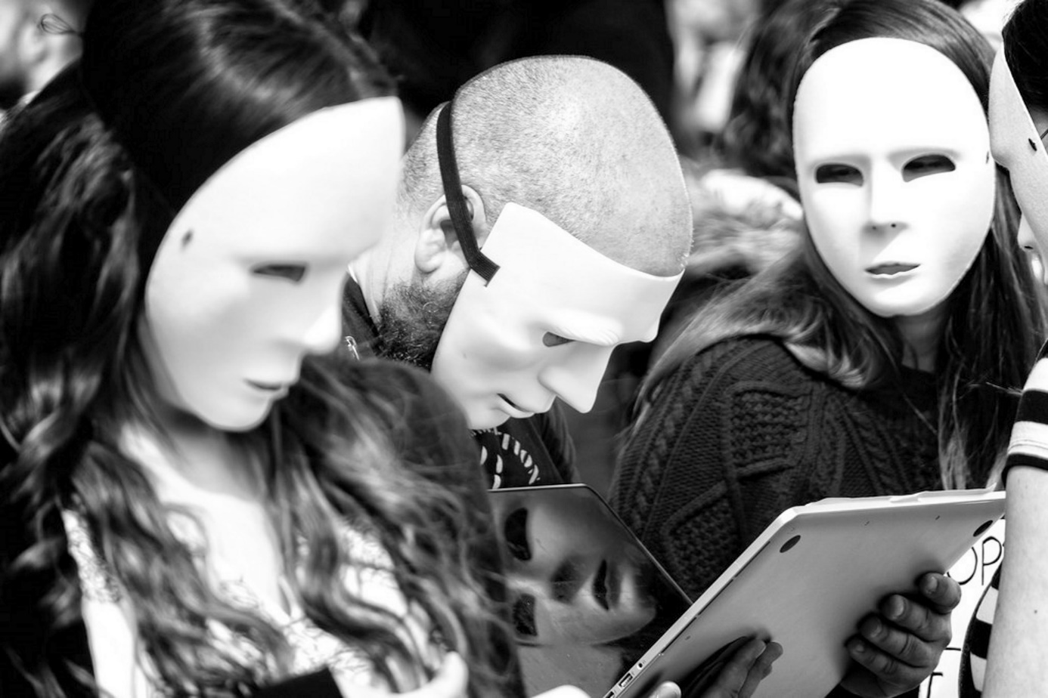

Question 12 (30 marks)

We need more purpose-built spaces for youth to ‘hang out’ other than the local shopping mall.

Contribute your perspectives on this topic through a convincing and persuasive text.

Question 13 (30 marks)

The future is possible. It might even be probable. But it’s not inevitable.

Use this statement to begin or end an imaginative text that is thought provoking.

Question 14 (30 marks)

Compose a narrative passage that draws on the context and point of view illustrated below.

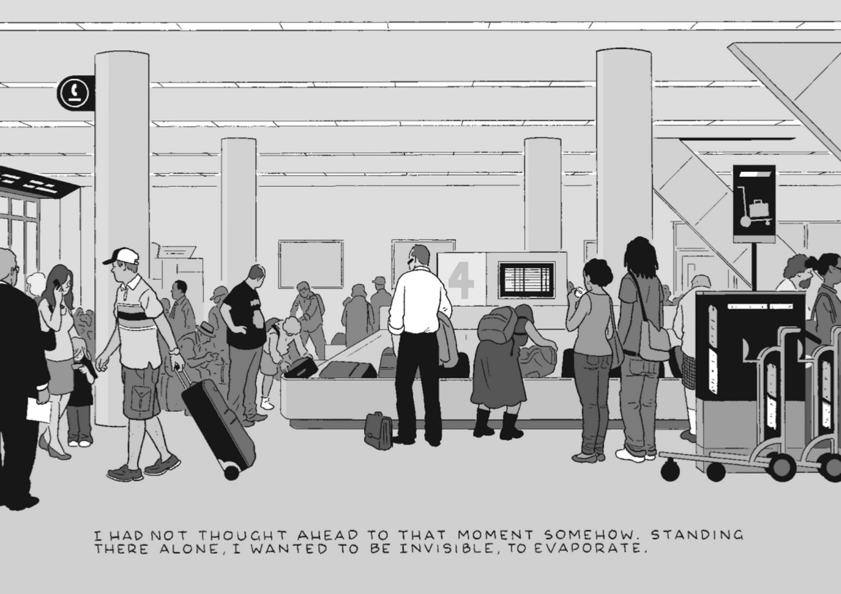

**ACKNOWLEDGEMENTS**

**Text 1** Aboulela, L. Extract from short story *The Ostrich*. Published by Intangible Publications, USA (1997).

**Text 2** Heller, P. Excerpt is from *The Whale Warriors*. Published by Simon & Schuster NY (2007).

**Text 3** Heller, P. Black and white version of cover: *The Whale Warriors*. Published by Simon & Schuster NY (2007).

**Question 10** Quote taken from *The Day of the Triffids* (1951), a novel by John Wyndham.

**Question 11** Knight, G. Image *Screenmask*, London Trafalgar Square (2016). Source: https://www.flickr.com/photos/garryknight/27598879423.

**Question 14** Tomine, A. Image sourced from the graphic novel *Killing and Dying*. Published by Drawn and Quarterly (2015).

© 2017 WA Exam Papers. Leeming Senior High School has a non-exclusive licence to copy and communicate this document for non-commercial, educational use within the school. No other copying, communication or use is permitted without the express written permission of WA Exam Papers. SN056-724-1.